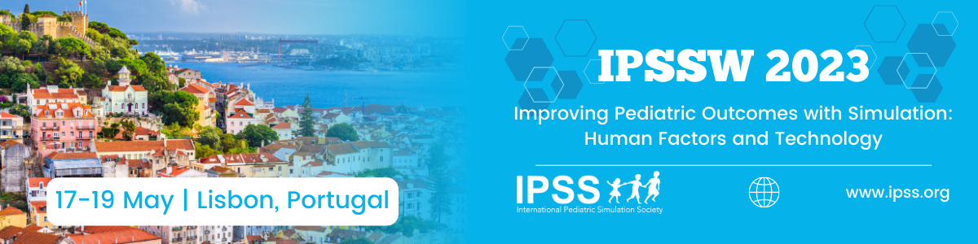

Innovation Abstract Submission Template for IPSSW2023

Abstracts are limited to 3000 characters including spaces and not including author names and affiliations or references.

For inclusion in the Conference Proceedings please bear in mind the following:
- Abstracts and proposals must be submitted electronically via on-line submission link: https://app.oxfordabstracts.com/stages/4909/submitter
  - The title should be no longer than 100 characters.
  - Graphs, tables and illustrations are allowed to be submitted as part of the abstract.

Please delete the instructions in green text and provide the following:

Title:
The title should be no longer than 100 characters.

Context:
Provide a description of the context in which the innovation was developed, implemented or evaluated. This may include a description of the need or problem that this work attempts to address, a rationale for why the innovation is necessary, and how the proposed innovation is novel or improves on existing methods. The significance for the pediatric healthcare simulation community should also be addressed. Include citations to relevant literature if appropriate.

Description:
Provide a detailed description of the innovation, such that other simulation practitioners may be able to adopt or replicate the approach taken by the authors. You may wish to include a description of the process used to develop the innovation, the target audience, the materials and techniques used to develop the innovation and how it was implemented in the given context.

Observation/Evaluation:
If a formal evaluation of the program was conducted, describe the approach to the evaluation and the subsequent results. If a formal evaluation was not conducted, describe any observations made during the implementation of the intervention, and the relevance of these observations to the design of the innovation. Tables or images may be included in this section as appropriate.

Discussion:
Discuss what was accomplished, the adequacy of the innovation in addressing the need or problem identified, any lessons learned from the implementation and/or evaluation of the innovation, and the potential utility for other simulation practitioners. Address any changes to the innovation that the authors recommend, and any follow-up work that may be required. Also discuss the implications of the work for the pediatric healthcare simulation community.

